|  |  |
| --- | --- |
| Anubhav Agarwal | [aa332@buffalo.edu](mailto:aa332@buffalo.edu) |
| Atish Kumar Dash | [adash2@buffalo.edu](mailto:adash2@buffalo.edu) |
| Bhumika Deo | [bdeo@buffalo.edu](mailto:bdeo@buffalo.edu) |
| Silky Batra | [silkybat@buffalo.edu](mailto:silkybat@buffalo.edu) |
| Sree Harika Datla | [sdatla@buffalo.edu](mailto:sdatla@buffalo.edu) |

**MGS 625: Management of IT Projects**

Prof. Mark Kwandrans

**Team D** Group Case Study: Assignment #2

Delta Consultancy Services Ltd.

Client: Elite Art Products – Case #2



**MGS 625 Group case study: assignment 2**

* **Instructions**

Submit a simple project schedule for the remainder of your student team’s work for this assignment (not for the implementation of Project Idea 1 or Project Idea 2), showing deliverables, due dates, and resource assignments. This could be completed in some project scheduling software but does not have to adhere to the “best practice” characteristics of a project schedule as presented in class or the text.

**Ans:** Please find below the project schedule, created with Smartsheet, featuring the following:

* 1. **A schedule of a project

     Description automatically generatedProject Schedule – Grid View**

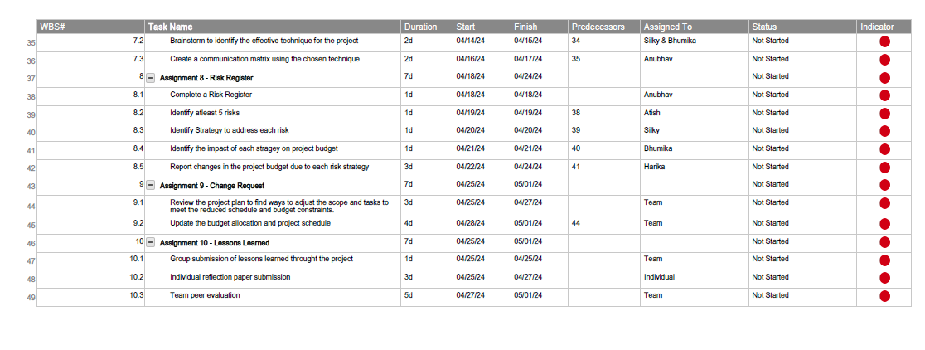

* 1. A graph with lines and dots

     Description automatically generated with medium confidence**Project Schedule – Gantt View**
* **Embedded Documents**
* **Project Schedule in Grid View**
  1. PDF: 
  2. Excel: 
* **Gantt View of the Project Schedule**
  1. Image: 
  2. PDF: 
* **Links**

1. **Project Schedule in Grid View**
   1. PDF: <https://drive.google.com/file/d/1bmhSdmTP0anNwP5WOW2MKwtMd3kM390v/view?usp=sharing>
   2. Excel: <https://docs.google.com/spreadsheets/d/1eMaNttvlHzsZs_QT-Fmq7oJ15WlkgRiV/edit?usp=sharing&ouid=103732064452610109806&rtpof=true&sd=true>
2. **Gantt View of the Project Schedule**
   1. Image: <https://drive.google.com/file/d/1wgHyD0qQSc3m4VbMQqrxnDDnhqFxqjw7/view?usp=sharing>
   2. PDF: <https://drive.google.com/file/d/1Z0cQncVolOq0tZnAnVQIY5F-_8EgqbxS/view?usp=sharing>